# Phase 5: Apex Programming (Developer)

This phase introduces the fundamentals of **Apex programming** in Salesforce. It includes object-oriented programming concepts, triggers, SOQL/SOSL, collections, control statements, and asynchronous processing. Below is documentation with **working code examples** and explanations for key concepts.

## 1️⃣ Classes & Objects

**Purpose:** Classes are blueprints for creating objects. They encapsulate variables (fields), methods (functions), and logic. Objects are instances of classes.

### Example: Attendee Handler Class

public class AttendeeHandler {  
   
 // Method to assign default status to new Attendees  
 public static void assignDefaultStatus(List<Attendee__c> attendees) {  
 for (Attendee__c att : attendees) {  
 if (String.isBlank(att.Status__c)) {  
 att.Status__c = 'Registered';  
 }  
 }  
 }  
   
 // Method to link Feedback to Attendee  
 public static void linkFeedback(List<Feedback__c> feedbackList) {  
 for (Feedback__c fb : feedbackList) {  
 if (fb.Attendee__c == null) {  
 fb.Attendee__c = [SELECT Id FROM Attendee__c LIMIT 1].Id;  
 }  
 }  
 }  
}

## 

## 2️⃣ Apex Triggers (before/after insert/update/delete)

**Purpose:** Triggers allow developers to execute custom logic **before or after DML operations** (insert, update, delete, undelete) on Salesforce records.

### EventFeedbackTrigger

trigger EventFeedbackTrigger on Feedback__c (after insert, after update, after delete, after undelete) {  
 Set<Id> eventIds = new Set<Id>();  
  
 if(Trigger.isInsert || Trigger.isUndelete){  
 for(Feedback__c f : Trigger.new) if(f.Event__c != null) eventIds.add(f.Event__c);  
 }  
  
 if(Trigger.isDelete){  
 for(Feedback__c f : Trigger.old) if(f.Event__c != null) eventIds.add(f.Event__c);  
 }  
  
 if(Trigger.isUpdate){  
 for(Feedback__c fNew : Trigger.new){  
 Feedback__c fOld = Trigger.oldMap.get(fNew.Id);  
 if(fNew.Event__c != null) eventIds.add(fNew.Event__c);  
 if(fOld.Event__c != null) eventIds.add(fOld.Event__c);  
 }  
 }  
  
 if(eventIds.isEmpty()) return;  
  
 // Aggregate query for feedback counts  
 Map<Id, Integer> eventToCount = new Map<Id, Integer>();  
 for(AggregateResult ar : [  
 SELECT Event__c e, COUNT(Id) cnt  
 FROM Feedback__c  
 WHERE Event__c IN :eventIds  
 GROUP BY Event__c  
 ]) {  
 eventToCount.put((Id) ar.get('e'), Integer.valueOf(String.valueOf(ar.get('cnt'))));  
 }  
  
 // Update Event records with new counts  
 List<Event__c> eventsToUpdate = new List<Event__c>();  
 for(Event__c ev : [SELECT Id, Feedback_Count__c FROM Event__c WHERE Id IN :eventIds]) {  
 Integer cnt = eventToCount.containsKey(ev.Id) ? eventToCount.get(ev.Id) : 0;  
 ev.Feedback_Count__c = cnt;  
 eventsToUpdate.add(ev);  
 }  
  
 if(!eventsToUpdate.isEmpty()) update eventsToUpdate;  
}

This trigger keeps the **Feedback_Count__c** field on the **Event__c** object up to date whenever feedback records are inserted, updated, deleted, or undeleted.

### Anonymous Apex Test Script

try {  
 // 1) Create Event  
 Event__c ev = new Event__c(Name = 'Trigger Test Event', Event_Date__c = Date.today().addDays(7), Event_picklist__c = 'Workshop', Attendee_Number__c = 10, Venue__c = 'Demo Venue');  
 insert ev;  
  
 // 2) Create an Attendee  
 Attendee__c at = new Attendee__c(Name = 'Test Attendee for Trigger', Event__c = ev.Id);  
 insert at;  
  
 // 3) Create Feedback records  
 List<Feedback__c> fbs = new List<Feedback__c>();  
 fbs.add(new Feedback__c(Name = 'Feedback 1', Event__c = ev.Id, Attendee__c = at.Id, Comments__c = 'Great event'));  
 fbs.add(new Feedback__c(Name = 'Feedback 2', Event__c = ev.Id, Attendee__c = at.Id, Comments__c = 'Loved it'));  
 insert fbs;  
  
 // 4) Query Event to check Feedback_Count__c  
 ev = [SELECT Id, Feedback_Count__c FROM Event__c WHERE Id = :ev.Id];  
 System.debug('Feedback count after insert: ' + ev.Feedback_Count__c);  
  
 // 5) Delete one feedback  
 delete fbs[0];  
 ev = [SELECT Id, Feedback_Count__c FROM Event__c WHERE Id = :ev.Id];  
 System.debug('Feedback count after delete: ' + ev.Feedback_Count__c);  
  
 // 6) Undelete feedback  
 undelete fbs[0];  
 ev = [SELECT Id, Feedback_Count__c FROM Event__c WHERE Id = :ev.Id];  
 System.debug('Feedback count after undelete: ' + ev.Feedback_Count__c);  
} catch (Exception ex) {  
 System.debug('Exception: ' + ex.getMessage());  
}

This is used in **Developer Console → Execute Anonymous** to test the **EventFeedbackTrigger** functionality.  
It creates sample **Event, Attendee, Feedback** records and verifies that the Feedback_Count__c field on Event__c updates correctly during **insert, delete, and undelete** operations.

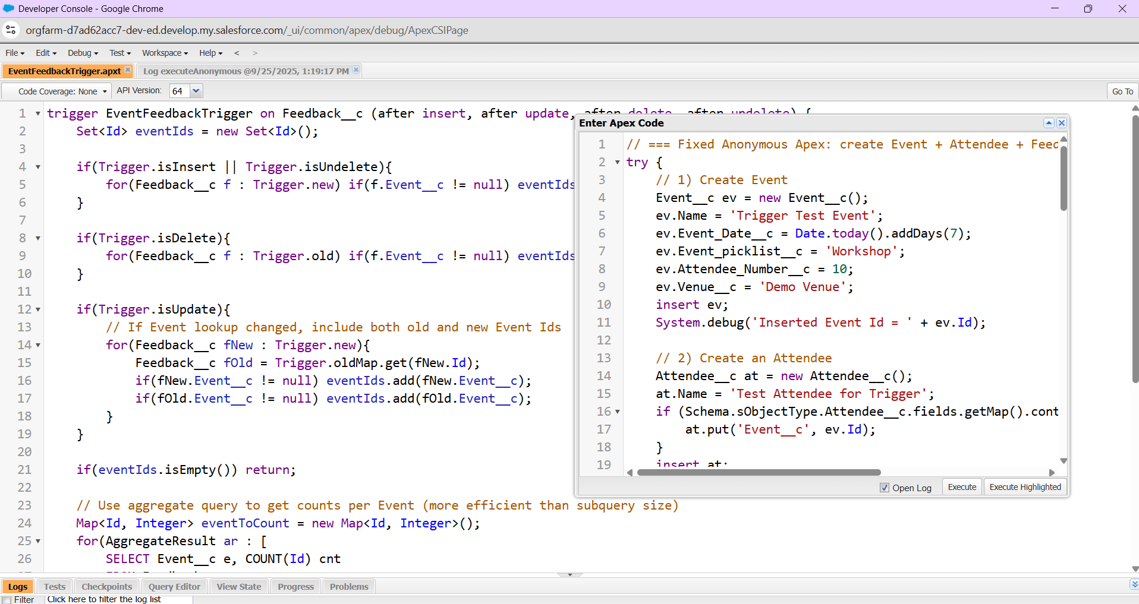

## 3️⃣ Trigger Design Pattern

* Keep triggers lean by delegating logic to **Handler Classes**.
* Ensure **one trigger per object**.
* Support bulk operations.
* Example: AttendeeTrigger calls AttendeeHandler.assignDefaultStatus().

## 4️⃣ SOQL & SOSL

* **SOQL**: Query records from a single object or related objects.
* List<Event__c> events = [SELECT Id, Name FROM Event__c WHERE Venue__c = 'Demo Venue'];
* **SOSL**: Search across multiple objects.
* List<List<SObject>> results = [FIND 'Workshop' IN ALL FIELDS RETURNING Event__c(Id, Name), Attendee__c(Id, Name)];

## 5️⃣ Collections: List, Set, Map

* **List**: Ordered collection.
* **Set**: Unique values.
* **Map**: Key-value pairs.

## 6️⃣ Control Statements

* Use if, for, while, switch for logic control.
* Bulkify loops and avoid nested SOQL queries.

## 7️⃣ Batch Apex

* Used for processing large data sets asynchronously in batches.
* Implement Database.Batchable interface.

## 8️⃣ Queueable Apex

* Asynchronous processing with the ability to chain jobs.
* More flexible than future methods.

## 9️⃣ Scheduled Apex

* Schedule Apex jobs to run at specific times.
* Implement Schedulable interface.

## 🔟 Future Methods

* Lightweight async execution for simple background tasks.
* Must be static and return void.

## 1️⃣1️⃣ Exception Handling

* Use try-catch-finally blocks.
* Catch DmlException and log errors properly.

## 1️⃣2️⃣ Test Classes

* Ensure at least **75% code coverage** for deployment.
* Test both positive and negative scenarios.
* Use @isTest annotation.

## 1️⃣3️⃣ Asynchronous Processing

* Includes Batch Apex, Queueable Apex, Scheduled Apex, and Future Methods.
* Improves scalability and avoids governor limit issues.

**IN MY PROJECT I MAINLY USED APPEX TRIGGER (before/after insert/update/delete) AND OTHER THING AUTOMATICALLY GOT IMPLIMENTED**